WELCOME TO The Georgian Loft Apartment

Hello and thank you for booking with mydublinvacation.com. We very much hope that you will enjoy your stay, please do not hesitate to get in touch if you would like any assistance.

Full address: 15 Talbot Street, Georgian Loft Apartment Dublin 1 Eircode: D01 V9P2

Contact name: Kevin Gormley Contact number: 00353 87 352 1962

Please confirm your check-in time as being 3pm unless otherwise arranged with me via text.
On the day of your arrival, drop me a text when you know when you will be arriving at the Coach House, so I can hand over keys and show you the workings of the house.
If I have your flight number, I will check for delays and will expect you at the Coach House around an hour after you have landed.

Getting to/from the airport:
A Cab from the airport should cost approximately €25. The journey time is around 25 mins.

If you require parking, you can park here, which is (a 3-minute walk away):
http://www.q-park.ie/parking-with-q-park/our-parking-facilities/dublin/q-park-clerys

Check-in is from 3pm, Check-out by 11am.
If you'd like to drop off bags/check-in earlier, let me know and we shall work something out.

Bedroom layout:
Bottom floor:
Bedroom 1 – 3x triple bunk bed
Living room – 2x sofa bed
Top floor:
Bedroom 2 – 3x triple bunk bed
Bedroom 3 – 2x single bed
Bedroom 4 – 1x single, 1x triple bunk bed

A triple bunk bed consists of a double bed on the bottom and a single bed on top, sleeping 3 total.
All the double and single beds are standard UK/Ireland sizes (54inch × 75inch and 35inch × 75inch).

Getting around

Walking is a great way to get around Dublin, especially given the location, the tram is also a great
option. Abbey street station is a 5-minute walk away.

Tram: Luas Red Line – Abbey street station https://www.luas.ie/interactive-map.html

Things to do
This is the best link for all things Dublin!... whether you're into literary tours, restaurants, historic buildings, walking tours, shopping or just hanging out, this website has it all: https://theculturetrip.com/?s=dublin

Here are a couple of local restaurants, all within walking distance https://www.opentable.co.uk/n/dublin/dublin-1/oconnell-street-restaurants

Temple Bar district is a 15-minute walk away, where you will find a whole array of pubs, bars and nightlife to cater for all occasions.

local amenities

The Celt Irish bar is an old, established pub, which hasn't changed in years and serves a great pint of Guinness.
The nearest supermarket is Tesco Express on Talbot street, a 2-minute walk away: https://www.tesco.com/store-locator/ie/?bID=5612
There are plenty of coffee shops and cafés within a very short walk.

Entrance to the Loft Apartment
Tesco Express
The Celt Irish Bar
Abbey street
Station

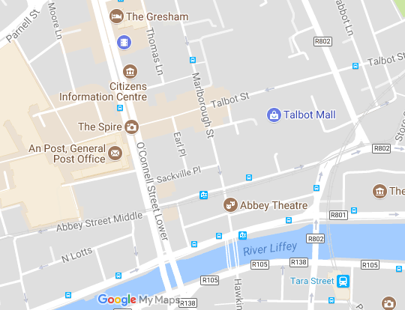
This way to Temple bar

WE HOPE YOU ENJOY YOUR STAY

